HOMEWORK

NAME: NATALI IZURIETA

COURS:3º”B” CONTABILIDAD

I must leave early

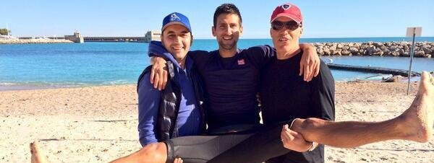The children must be back by four

 I must stop smoking

You must do your homework



***must* go to the library.**

 **You *must* stay here until I come back.**

. **We *must* be at the airport at three o'clock.**

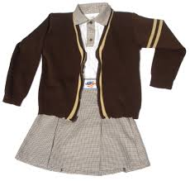. **Everybody *must* wear a uniform.**

.**We mustn't make noise.**

  
Must you go? (¿Tienes que irte?